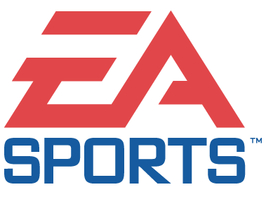

PRESENTS: | XBOX™
NCAA® Football 2003

Product Description
NCAA® Football 2003 relives the intensity, pageantry and spirit of college football and celebrates the loyalty and tradition of college football’s storied football programs. No other college football game creates the experience of the intense rivalries of college football Saturday’s at all 117 Division I-A and 27 I-AA schools across the country. NCAA Football 2003 brings all which is special to college football -- the schools, the unique formations and plays, the band music, the cheerleaders, the mascots -- creating a very different, unique gaming experience from that of professional football. NCAA Football has been the dominant player in the college football video game market for many years.

Key Features
- College Atmosphere: New 3D cheerleaders and 25 new mascot teams to root on your favorite teams; new team-specific chants and fight songs echoing the sounds of college football like never before; all 117 Division 1-A stadiums creating a true-to-life environment; new pre-game presentation with school-specific entrances; improved player detail -- including larger uniform patches, new player faces and textures.
- Rival Game Mode: Play against your school’s archenemy for a chance to win one of 23 coveted rivalry trophies.
- Trophy Room: Show off your personally engraved memories of your major victories.
- Improved Gameplay: New plays and formations -- including new option variations and dynamic WR splits; new animations -- including standing catches, stiff arm, broken tackles, speed options, spin moves, receiver routes; new control mechanics -- defensive coach cam, defensive swat, etc.; major Al improvements -- enhanced running game, defense pass coverage, and blocking schemes; Defensive play diagrams -- review offensive and defensive assignments drawn on the field.
- Create-A-School: Create a team and build a national powerhouse in every game mode, including season and dynasty. Customize everything from the school name and nickname to the uniform and fight song.
- Dynasty Mode™: New custom schedules -- choose your non-conference and non-traditional games; authentic schedules -- neutral-site games and classic match-ups; off-season improvements -- coaching strategies like recruiting, cutting.
- More Teams: Mascot teams -- play a complete game with one of the 50 mascot teams available; new 2001 All-American Team.
- Sound Enhancements: Improved TV commentary with less repetition and more in-game content from the broadcast super team of Kirk Herbstreit, Brad Nessler and Lee Corso.
- New Interface: Fully rendered player helmets with dynamic lighting; team flags -- animated team flags waving on the main menu screens; Coach hat/clipboard -- 3D coach hat/clipboard to represent the coaches; interactive players -- in create-a-player, watch your player’s appearance transform on screen with new equipment.
- My NCAA: Active Profile personalizes it more and keeps it simple, including easier saving with auto-loading and auto-saving;
- Also available for Nintendo GameCube™ and PlayStation® 2.

Product Specifications:
Publisher: Electronic Arts
Developer: Electronic Arts Tiburon
Ship Date: Summer 2002
Category: Sports

© 2002 Electronic Arts Inc. All rights reserved. All trademarks are the property of their respective owners

